USER MANUAL

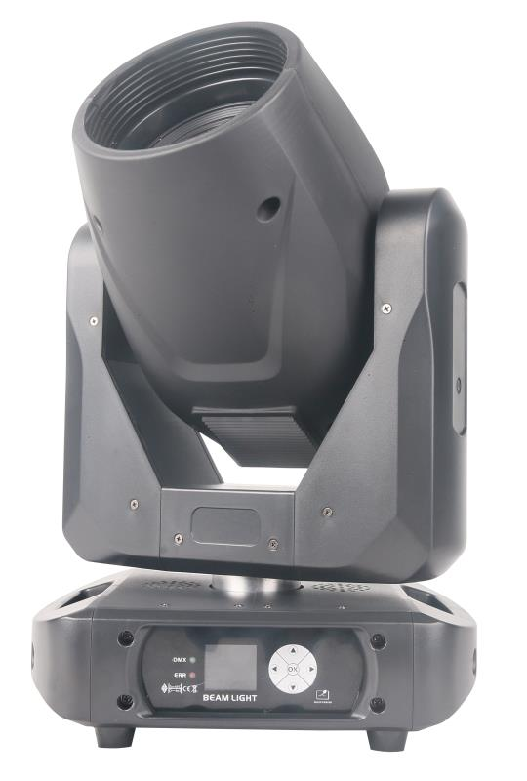
251 BEAM

Please keep read this manual carefully for further use!

Thank you for buying our professional Beam moving head.
This user manual includes important information for installation and operation, so please read this user manual carefully before installation and operation, and keep this user manual well for further use.
In order to install , operate, and maintain the lighting safety and correctly. We suggest that the installation and operation should be done by the verified technician and follow the instruction strictly.
Spare part includes:
Name | QTY | Unit
Fixture | 1 | PC
User manual | 1 | PC
Power cable | 1 | PC
DMX Cable | 1 | PC

Please check carefully that there is no damage caused by transportation. Should there be any, consult your local dealer.
Cautions
Before delivery, this device has passed strict inspection, Please follow the user manual strictly for operation, if this fixture is damaged by improper operation and mistake, the fixture will be out of warranty, and manufacture or dealer won’t be responsible for it. In case of any technology change in this manual,we won’t advise in further .



CAUTION!

Keep this device away from rain and moisture!

Unplug mains lead before opening the housing!

Warning!

Silkscreen symbol on light
Damages caused by the disregard of this user manual are not subject to warranty. The dealer will not accept liability for any resulting defects or problems.

Installation
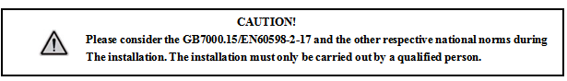

► This fixture is not suitable for direct installation on combustible material surface, please keep the fixture surface at least 0.5m from any combustible material.

► If you use the quick lock cam in hanging up the fixture, please make sure the quick lock fasteners turned in the quick lock holes correctly.
►The applicable temperature for the fixture is between -25°C to 45°C. Do not use the lighting under or above this temperature range.
►The truss for hanging the fixture should be able to hold 10 times weight of this fixture and no deformation after 1 hour hang.
►Please don’t stand under the fixture when install, uninstall, move or repair the fixture.
►Please ensure the light is connected correctly and invite professional technician to check and confirm the electrical data before installation.
►Please invite professional technician to check the fixture and installation each year.
Rigging：
Clamp
Bracket

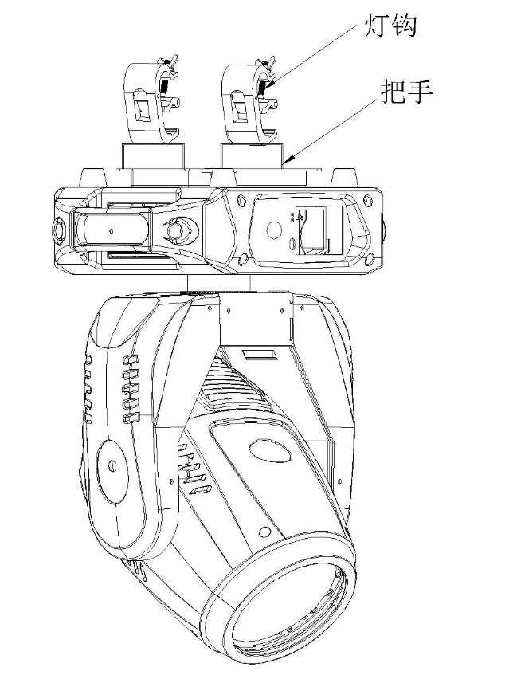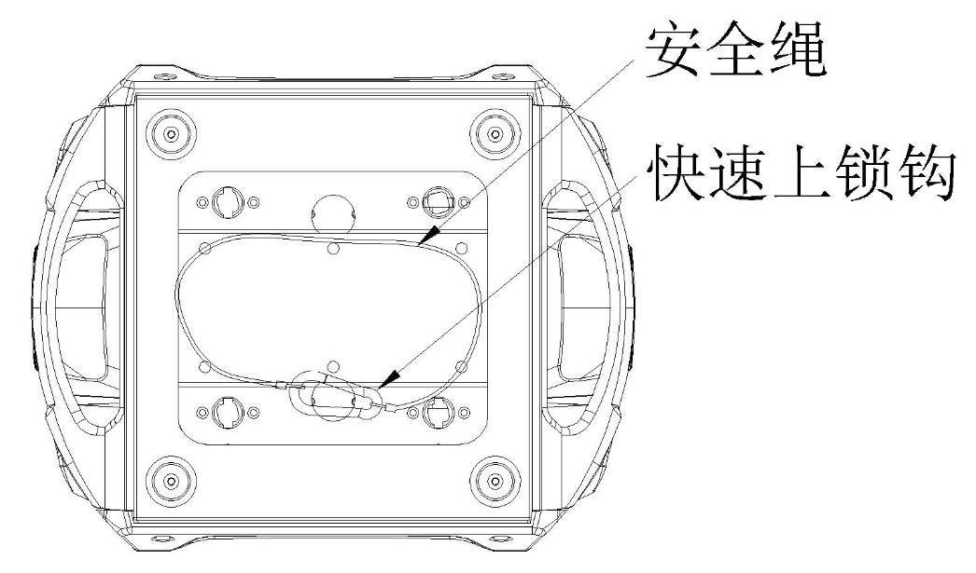
Safety rope

Quick lock

Insert the quick-lock fasteners of the first holder into the respective holes on the bottom of the device.Tighten the quick-lock fasteners fully clockwise.
Fix the clamp on truss or other fixture bracket.
Pull the safety rope through the holes on the bottom of the base and fasten it on the truss or other fixing point.
Note:This step is quite important to ensure that fixture will not drop down for the clamp damage.

Product specification

1. Voltage：100-240V，50/60HZ；
2. Power Consumption：400W；
3. Lamp: 250W
4. Average lifetime:2000hours； Color Temp: 8000K；
5.Pan：540°(16bit) electronic error correction；
6.Tilt：270° (16bit) electronic error correction；
7.Color wheel:14 colors+white
8.Gobo wheel:13 gobos+white
9.Prism: big-angle honeycomb prism
10.Frost and 6-color wheel effect；
11. Electrical dimming：0%~100%；support strobe at various speeds, strobe color marco
12. Beam angle：2.4º
13. Over-heat protection；Display：LCD
14. IP rate:IP20；
15.Product size：340*255*515mm；
16.outer carton size: 440*410*540mm；
17.N.W：14.6KG；

Display and operation

Panel description
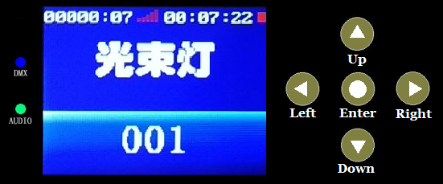

DMX | DMX signal indicator
AUDIO | Indicator light when AUDIO is triggered
Up | to select upward
Down | to select downward
Left | to select left / return
Right | to select right
ENTER | To Confirm
Time on the left side of the screen | The total time the system is in use (the display can be turned off in the standard settings)
Time on the right side of the screen | The total time of this power-on (can be turned off in the standard settings)
Vertical signal at the top of the screen | Current DMX signal connection signal strength  Red: No signal. White: Current signal strength
Square icon in the upper right corner of the screen | Green: normal, no errors
Square icon in the upper right corner of the screen | Red: There is an error (click the icon or "Information Menu/Error Message/View" to view the error

Display operation interface:
D
Standard | Default set | Enter? | Restore factory default parameters
Standard | Address | 001-512 | Set address code
Standard | DMX mode | Mode1  Mode2  Mode3  Mode4 | Select DMX control mode
Standard | Effect mode | No/Yes | effect disc automatically finds the shortest distance rotation operation
Standard | Started lamp | Off/on | Choose whether to turn on the bulb every time it is "on" or "off"
Standard | Switch lamp | Off/on | Turn on the light bulb manually
Standard | No signal | Clear  Hold | Keep DMX value or clear DMX channel value when there is no DMX signal
Standard | UI Color | Green  Blue  Golden  Gray | Choose screen menu color
Standard | Show time | No/Yes | Show running time timer on the main interface
Standard | Brightness | 000-255 | Adjust screen brightness
Standard | Screensaver | Off/On | Turn off the screen when there is no touch or key operation
Standard | XY encoder | No/Yes | Cancel or use XY automatic error correction function
Standard | X inversion | No/Yes | Select X axis forward or reverse operation
Standard | Y inversion | No/Yes | Select Y-axis forward or reverse operation
Standard | Focus inversion | No/Yes | Select the focus axis to run in the forward or reverse direction
Standard | Zoom inversion | No/Yes | Select the magnifying axis to run in the forward or reverse direction
Advanced | This setting is the main parameter setting of the lamp and requires permission
Info | Error List | No error/View | If there is no error or there is an error, click OK to view the error
Info | System ver | Vxxxxxxx | System version information
Info | Serial NO. | xxxxxxxx | Equipment factory number
Info | SYS timer | 00000.0H | Total running time of the system (hours)
Info | Run timer | 000:00 | Running time of this power-on (hours)）
Info | Lamp timer | 00000.0H | The total time the bulb on (hours)）
Info | Equip TEMP | 000 | The temperature of the main part of the equipment (need equipment support)
Info | Head TEMP | 000 | The temperature of the lamp head of the device (requires device support)
Info | FAN 1 Speed | 0000 RPM | fan 1 speed (requires equipment support)
Info | FAN 2 Speed | 0000 RPM | fan 2 speed (requires equipment support)
perform | Run mode | Auto/Sound | Auto/Sound operation
perform | Run speed | 255 | Auto operation speed
perform | Run cross | 255 | Set sliding steps for Auto/Sound operation (device support is required)
perform | Built-in 1 | Off/On | built-in test program 1
perform | Built-in 2 | Off/On | built-in test program 2
perform | User PRO 1 | Off/On | User self-programming program 1
perform | User PRO 2 | Off/On | User self-programming program 2
perform | User PRO 3 | Off/On | User self-programming program 3
perform | User PRO 4 | Off/On | User self-programming program 4
perform | Circle shape | Off/On | (Reserved)
perform | Shpae shape | Off/On | (Reserved)
perform | Shape range | 000 | (Reserved)
perform | Sound DB | 000 | Adjust Sound control sensitivity
Program | (Explain in detail on the next page)
Reset | System reset to initial position

Function Description
Manual control or programming function description:
1: This function can program up to 4 user programs, 4 programs can be run in series, that is to say, the 4 programs that have been programmed can be switched to on at the same time in the "Test Run" function, and program 1 is run first when running , Then to program 2, to program 3, then program 4, and then loop back to program 1, and so on and so on. Of course, you can also single-select operation.
2: Operations that can be achieved by programming function buttons:
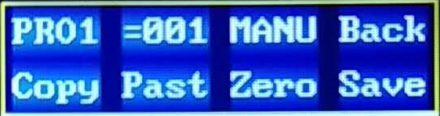
Select program, read program, select step, delete step, manual or console input, copy current step, paste to selected step, clear current step, save to selected program space

Manual control:
Manual/Console Press the up, down, left, and right buttons and the OK button to select the mode button to the manual position.
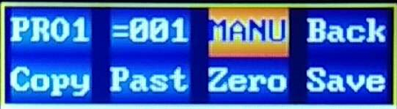
Then operate the up, down, left, and right buttons and the OK button to make the corresponding channel red, and press the up and down buttons to manually control.
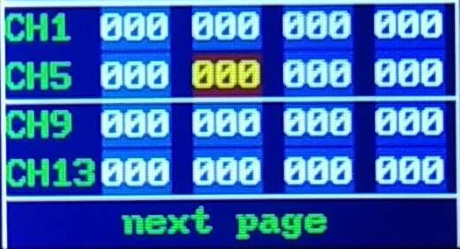

Manual control programming:
Select the PRO1-4 that needs to be saved, and after setting the channel value of one step through manual control, click the step (number button is the step) as shown in the figure, and press the up and down buttons to go to the next step. Then manually control and set the channel value, and the next step is and so on..

Delete step:
If there are too many programming steps, the following steps can be deleted. Select the step button and press the "Down" button to return to the previous step that is not needed. At this time, the number of the step is displayed as> 0XX. At this time, press and hold the OK button for 3 seconds, and the following steps can be deleted. The display becomes =0XX.
Copy step:
Press the copy button to copy all channel values ​​of the current step and temporarily store them in the memory pasteboard.
Paste step:
After copying, you can select any step, and paste the channel value of the pasteboard into the currently selected step channel.
Clear step:
Press the reset button to reset the channel value of the current step to zero.

Console control programming:
This device provides a more convenient console input programming function, and you can also use this function to enter the console program step by step to realize the function of copying the program programmed by the console.
As shown in the figure, select the manual/control console input mode as the console.
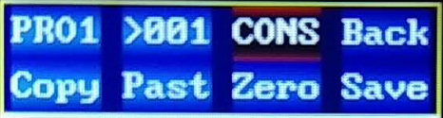
At this time, all channel values ​​are input by the DMX console, manual invalid, paste invalid, clear invalid, all channel values ​​display DMX values ​​in real time.
At this time, programming only needs console input, or the console runs the programmed steps in a single step, that is, enters the console program. This device only needs to click the next number and press the up arrow to realize programming.

Save the program:
After programming each step by manual input or console input, you can save this programming. Please make sure to select the save location PRO1--PRO4, please note that the saved step length is equal to the step value = 0XX, instead of seeing the step value> 0XX. Please delete the unnecessary steps later, refer to (Delete Steps", and then press Save.

Read the program and re-edit the program:
As shown in the figure, select the PRO1--PRO4 to be read out, then click the step button, and press the <Down> button to display "Read Out". Press the OK key at this time to read the selected program. The value displayed after reading is the maximum step value of the current program. If the program is empty, it will display as "Empty" or "No"
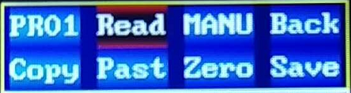
At this time, you can re-edit the program that has been read out. After editing, press Save to overwrite the current program, or select another PRO1--PRO4 space to save as.

Run the program:
If you need to run the programmed and saved program, please return to the "Test Run/Perform" function menu, click to select the corresponding user program, and switch to "On".
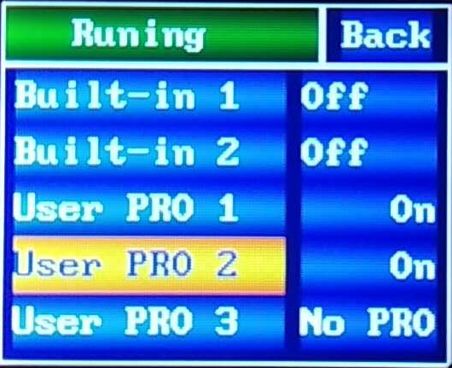

Fixed Gobo Wheel and color wheel

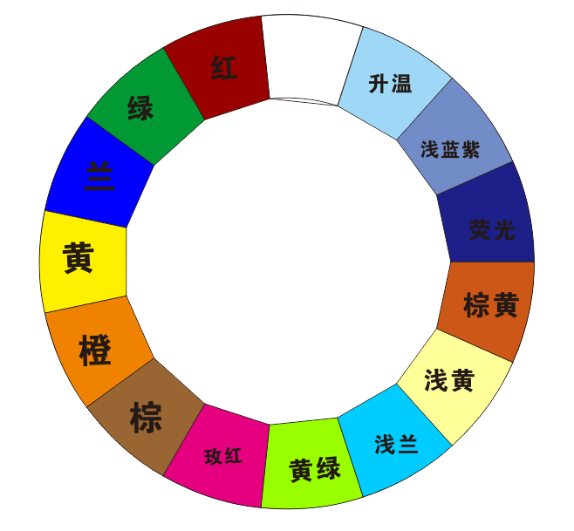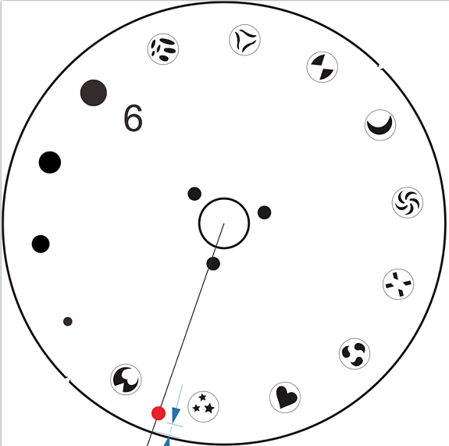

Six-color effect

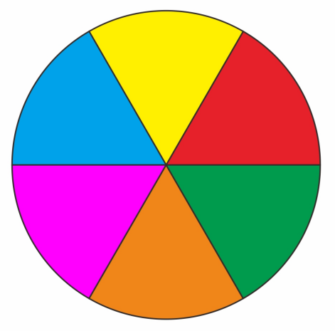

DMX channel
Channel | Effect | Value | Description
CH1 | Color | 000-004 | White
CH1 | Color | 005 -009 | White+ color 1
CH1 | Color | 010 - 014 | Color 1
CH1 | Color | 015 - 019 | Color 1+ color 2
CH1 | Color | 020 - 024 | color 2
CH1 | Color | 025 - 029 | color 2+ color 3
CH1 | Color | 030 - 034 | color 3
CH1 | Color | 035 - 039 | color 3+ color 4
CH1 | Color | 040 - 044 | color 4
CH1 | Color | 045 - 049 | color 4+ color 5
CH1 | Color | 050 - 054 | color 5
CH1 | Color | 055 - 059 | color 5+ color 6
CH1 | Color | 060 - 064 | color 6
CH1 | Color | 065 - 069 | color 6+ color 7
CH1 | Color | 070 - 074 | color 7
CH1 | Color | 075 - 079 | color 7+ color 8
CH1 | Color | 080 - 084 | Color 8
CH1 | Color | 085 - 089 | Color 8+color 9
CH1 | Color | 090 - 094 | Color 9
CH1 | Color | 095 - 099 | Color 9+color 10
CH1 | Color | 100 - 104 | Color 10
CH1 | Color | 105 - 109 | Color 10+color 11
CH1 | Color | 110 - 114 | Color 11
CH1 | Color | 115 - 119 | Color 11+color 12
CH1 | Color | 120 - 124 | Color 12
CH1 | Color | 125 - 129 | Color 12+color 13
CH1 | Color | 130 - 134 | Color 13
CH1 | Color | 135 - 139 | Color 13+ Color 14
CH1 | Color | 140- 144 | Color 14
CH1 | Color | 145- 149 | Color 14+White
CH1 | Color | 150 - 200 | Rainbow effect forward rotation from slow to fast
CH1 | Color | 201 - 255 | Rainbow effect reverse rotation from slow to fast
CH2 | Strobe | 000 - 003 | Off
CH2 | Strobe | 004 - 103 | Strobe from slow to fast
CH2 | Strobe | 104 - 107 | On
CH2 | Strobe | 108 - 207 | Pulse strobe from slow to fast
CH2 | Strobe | 208 - 212 | On
CH2 | Strobe | 213 - 251 | Random strobe from slow to fast
CH2 | Strobe | 252 - 255 | On
CH3 | Dimmer | 000 - 255 | Dimmer from 0-100%
CH4 | Gobo | 000 - 004 | Gobo 1
CH4 | Gobo | 005 - 009 | Gobo 2
CH4 | Gobo | 010 - 014 | Gobo 3
CH4 | Gobo | 015 - 019 | Gobo 4
CH4 | Gobo | 020 - 024 | Gobo 5
CH4 | Gobo | 025 - 029 | Gobo 6
CH4 | Gobo | 030 - 034 | Gobo 7
CH4 | Gobo | 035 - 039 | Gobo 8
CH4 | Gobo | 040 - 044 | Gobo 9
CH4 | Gobo | 045 - 049 | Gobo 10
CH4 | Gobo | 050 - 054 | Gobo 10
CH4 | Gobo | 055 - 059 | Gobo 12
CH4 | Gobo | 060 - 064 | Gobo 13
CH4 | Gobo | 065 - 069 | Gobo 14
CH4 | Gobo | 070 - 074 | Gobo 1 shake from slow to fast
CH4 | Gobo | 075 - 079 | Gobo 2 shake from slow to fast
CH4 | Gobo | 080 - 084 | Gobo 3 shake from slow to fast
CH4 | Gobo | 085 - 089 | Gobo 4 shake from slow to fast
CH4 | Gobo | 090 - 094 | Gobo 5 shake from slow to fast
CH4 | Gobo | 095 - 099 | Gobo 6 shake from slow to fast
CH4 | Gobo | 100 - 104 | Gobo 7 shake from slow to fast
CH4 | Gobo | 105 - 109 | Gobo 8 shake from slow to fast
CH4 | Gobo | 110 - 114 | Gobo 9 shake from slow to fast
CH4 | Gobo | 115 - 119 | Gobo 10 shake from slow to fast
CH4 | Gobo | 120 - 124 | Gobo 11 shake from slow to fast
CH4 | Gobo | 125 - 129 | Gobo 12 shake from slow to fast
CH4 | Gobo | 130 - 134 | Gobo 13 shake from slow to fast
CH4 | Gobo | 135 - 139 | Gobo 14 shake from slow to fast
CH4 | Gobo | 140 - 200 | Reverse flow (from fast to slow)
CH4 | Gobo | 201 - 255 | Forward flow (from slow to fast)
CH5 | Prism | 000 - 063 | No function
CH5 | Prism | 064 - 127 | Prism 1
CH5 | Prism | 128 - 191 | Prism 2
CH5 | Prism | 192 - 255 | Prism 1 + Prism 2
CH6 | Prism Rotation | 000 - 127 | angle
CH6 | Prism Rotation | 128 - 190 | Reverse rotation from fast to slow
CH6 | Prism Rotation | 191 - 192 | Stop
CH6 | Prism Rotation | 193 - 255 | Forward rotation from slow to fast
CH7 | Frost+6-color | 000 - 127 | No function
CH7 | Frost+6-color | 128 - 191 | 6-color
CH7 | Frost+6-color | 192 - 255 | Frost
CH8 | Focus | 000 - 255 | Focus
CH9 | Focus fine | 000 - 255 | Focus fine
CH10 | Pan | 000 - 255 | 0-540 degrees
CH11 | Pan fine | 000 - 255 | 0-2.1 degrees Pan fine
CH12 | Tilt | 000 - 255 | 0-270degrees
CH13 | Tilt fine | 000 - 255 | Tilt fine
CH14 | Pan/Tilt speed | 000 - 255 | Speed from fast to slow
CH15 | Auto | 000 - 127 | No function
CH15 | Auto | 128 - 145 | Random auto
CH15 | Auto | 146 - 255 | No function
CH16 | Lamp control | 000 - 099 | No function
CH16 | Lamp control | 100 - 105 | Delay Off
CH16 | Lamp control | 106 - 199 | No function
CH16 | Lamp control | 200 - 205 | Delay On
CH16 | Lamp control | 206 - 249 | No function
CH16 | Lamp control | 250 - 255 | Reset after 3 sec
DMX-512 connection

Connect the provided XLR cable to the male 3-pin XLR output of your controller and the other side to the female 3-pin XLR input of the light.then connect the DMX signal to the first fixture to the 2nd fixture, after all fixtures are connected,

The signal cable should be two - core with screened cable with XLR input and output connectors. Please refer to the diagram below

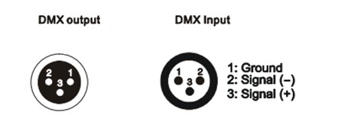
DMX Address setting
Each fixture must set a specific starting address. When receiving signal transmission, fixture will receive channel control signals which from the starting address.
According to different requirements or easy to use, the user can set many value fixtures to the same address, also can set up a separate address for every device.
If you set the same address,all the devices will receive from DMX channels signal. All connecting fixtures are jointly controlled, controller can't separate control a device.
If you set a different address, each device will be separate from its particular set the starting address and begin accepting DMX512 control signal, so that more convenient separate control one device. Using this method must be based on channel quantity of device to determine a starting address.
This light has 16 channels.you should set the starting address of the first unit to 1, the second unit to 17(1 + 16), the third unit to 33 (16*2+ 1), and so on.

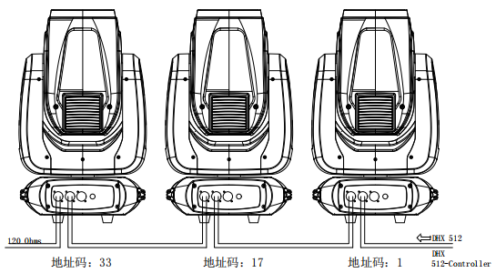
Cleaning and maintenance

Cleaning should be performed every 15-day period, by using a sponge which is dipped with alcohol, rather than wet cloth or other chemical liquid, to clean the mirror.

Cut off power before cleaning and maintenance!
CAUTION

Attention

Do not see directly light source when open the light, and make sure power off before do any installation or maintenance.

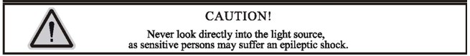

 Wires connection must be done professional person!
CAUTION

Cautions
Before delivery, this device has passed strict inspection, Please follow the user manual strictly for operation, if this fixture is damaged by improper operation and mistake, the fixture will be out of warranty, and manufacture or dealer won’t be responsible for it. In case of any technology change in this manual,we won’t advise in further .

Common issues instruction
Issues | Solve instruction
No power | Check power’s voltage
When power in, output light but the device cannot accept control signal | Check address setting and the control DMX cable connection well or not
The effect have light shadow | Check electronic focus DMX channel value, does suitable distance
Power down | The lamp maybe arrived end of using life, should change new lamp, and also check light source cleaning or not
Note: the maintenance should be done by the verified technician.

Warranty Card
This product is made of high-brightness transistor. We will provide 1 year warranty under the condition that user has operated the light normally and lifetime service. We won't provide warranty if the damage is caused by artificial or force majeure event. Cost of fittings should be charged by user if product need maintenance after 1 year .Please cut this warranty card and shipped it along with the product to our factory when applying for warranty.
Product：
Purchasing date：
Code of invoice：
Warranty date: From To
User’s name： Add：
Company： Tel：

